

***LAB HELPER ONLINE SYSTEM***

**Final Year**

**BSc. Hon. Computers System Dissertation**

Author: Beni Iyaka

Supervisor: Stephen Gill

13/04/2016

Lab Helper System

By

Beni Iyaka

Supervisor: Dr. Steve Gill

Second Reader: Dr. Andrew Ireland

A project report submitted to the school of Mathematics and computer systems in partial fulfillment of the requirement for the Bachelors of Science Heriot Watt University

Division of Mathematics and Computer System

Dubai Campus

2015/2016

**Declaration**

I, Beni Iyaka affirm that this work submitted for evaluation is my own particular and is expressed in my own particular words. Any utilization made inside of it of the works of different authors in any structure is appropriately recognized anytime of their utilization. A rundown of the references utilized is incorporated.

**Abstract**

The aim of this dissertation was to develop a system where staff can input labs that require help. This include the course name, Day of the week, start time and duration, start week and end week. These requests would be then published to students registered with the system.

The system allows students to create profiles and send requests to help in various labs published by lecturers. The request would be approved or rejected by the lecturer requesting the lab helper.

**Acknowledgement**

I wish to express my sincere gratitude to my project supervisor Dr. Steve Gill for his guidance, support and encouragement throughout the development of the system. I will also like to convey my heartfelt appreciation to the Heriot Watt University Dubai Campus Instructors for their contributions and ideas.

Table Contents

Declaration………………………………………………………………………………………………i

Abstract………………………………………………………………………………………………….ii

Acknowledgement……………………………………………………………………………………..iii

Table of Contents……………………………………………………………………………………...iv

1. Introduction…………………………………………………………………...………………….. 1
   1. Background…………………………………………………………...……………………… 1
   2. Objective……………………………………………………………………………………… 1
   3. Used terms Definition…………………………………………………………………..... 2
   4. Methodology………………………………………………………………………………….. 2
   5. User Characteristic…………………………………………………………………………. 2
2. Literature review…………………………………………………………………………………. 3
   1. Introduction………………………………………………………………………………….. 3
   2. Decision Theories…………...………………………………………………………………. 3
      1. Decision Support System………….……………….……………………………… 4
      2. Expert System………………………….………….…………………………………6
      3. Management Information System……………..………………………………….7
      4. Conclusion on Information System…………………………...…………………. 9
   3. Approaches to Designing an Information System……………………………………... 9
      1. Traditional Systems Life Cycle………………………………………………..… 11
      2. Prototyping…………………………………………………………………………. 11
      3. Software package…………………………………………………………………... 11
      4. End-user development…………………………………………………………….. 11
      5. Conclusion on design methods…………………………………………………… 12
   4. Web-Based Information Systems……………………………………………………….. 13
   5. Conclusion…………………………………………………………………………………... 13
3. Requirement Analysis………………………………………………………………………….. 14
   1. Introduction…………………………………………………………………………………14
      1. Purpose………………………………………………………………………………..14
      2. Scope…………………………………………………………………………………. 14
      3. Overview…………………………………………………………………………….. 15
   2. General Description……………………………………………………………………… 16
      1. Product Perceptive………………………………………………………………… 16
      2. General Capabilities………………………………………………………………. 17
   3. General Constraints……………………………………………………………………... 22
   4. User characteristics……………………………………………………………………… 22
   5. Specific requirements…………………………………………………………………… 23
   6. Constraints requirements………………….…………………………………………… 24
      1. Hardware……………………………………………………………………………. 24
      2. Software..……………………………………………………………………………. 24
      3. Data…….……………………………………………………………………………. 24
      4. Security...……………………………………………………………………………. 24
      5. Legislation…..………………………………………………………………………. 24
      6. Usability.……………………………………………………………………………. 24
4. Evaluation Plan…………………………………………………………………………………. 25
   1. Introduction…………………………………………………………………………….. 25
   2. Purpose……...…………………………………………………………………………….25
   3. Method…………………………………………………………………………………….25
      1. Design Expert Review……………………………………………………………. 26
      2. One on one review………………………………………………………………….. 27
5. Project Plan………………………………………………………………………………………. 28
   1. Purpose…………………………………………………………………………………... 28
6. Scope Management……………………………………………………………………………... 31
   1. Definition………………………………………………………………………………… 31
7. Change Control Management…………………………………………………………………. 32
8. Schedule Managemt…………………………………………………………………………….. 33
9. Milestones………………………………………………………………………………………… 34
10. Quality Management…………………………………………………………………………….34
11. Risk Management………………………………………………………………………………. 35
    1. Introduction……………………………………………………………………………... 35
    2. Risk Register..…………………………………………………………………………... 36
    3. Impact with probability...……………………………………………………………... 37
12. System Design…………………………………………………………………………………... 39
    1. Website…………………………………………………………………………………… 39
    2. Database….…………………………………………………………………………....... 40
13. Implementation………………………………………………………………………………….. 44
14. Testing & Evaluation…………………………………………………………………………… 50
15. Discussion………………………………………………………………………………………….
16. Conclusion………………………………………………………………………………………….84
17. **Introduction**
    1. **Background**

Lab helper is someone who assists with work in information Technology Laboratory for teaching practical lessons such as programming. These mostly are 4th-year students and master’s students; of which their main duties are to:

* Prepare lab sessions.
* Assisting students that are struggling.
* Maintaining the lab.
* Preparing in advance for the lab period.

For many years, Universities are making use of the lab helper but do not use a system to management them. Mostly, this system helps them post vacant position in the system when needs arise and because of that, many students are not aware of opportunities. Therefore, I will be developing a system that will help improve that by developing a system that can help them put out a word to students and also allow those that are interested in applying for them.

* 1. **Objective**

The objective of this project is to develop a lab helper system based on Microsoft window application with structure query language as the backend database for the lab helper system. For this project, I have broken down the system object into two categories namely functional and nonfunctional objectives.

**Functional objectives of the system**

1. Allow the instructors to upload labs that require help.
2. Input course name, the day of the week, start time and duration, start week and end week, skills needed and the number of helpers required.
3. Students should create a profile before applying by inputting the skills their poses and then apply for the position most suited for them.
4. Instructors would need to approve their request
5. An automatic email should be sent to the student for confirmation of acceptance.

**Nonfunctional objectives of the system**

1. Maintainability: the system should be easy to maintain once faulty.
2. Flexibility: the system should be easy to modify.
3. Manageability: the system should be easily manageable.
4. Usability: the system should be easy to use and accurate.
5. Security: the personal information should be confidential and not accessible to anyone else but the owner.
   1. **Used terms Definition**

MS SQL Microsoft Query Language

GUI Graphical User Interface

RAM Read Access Memory

EDM Entity Data Model

LHS Lab Helper System

* 1. **Methodology**

This project, LHS, is developed using PHP and Microsoft SQL Server database.

* 1. **User Characteristic**

From the requirement specification, it is stated that all users of the software program are required to be members of the university with the following characteristic:

* All users must have a student/employee number.
* Users must have knowledge in the programming.
* Users must have a basic knowledge to use this software.

1. **Literature review** 
   1. **Introduction**

The purpose of a literature review is to look into pre-existing materials relevant to this project. Decision theories and how Information System has been used in other organization will be discussed in this chapter. Alongside this, it is also important to look at different advantages and disadvantages that the system may bring along.

* 1. **Decision Theories**

To get an understanding of how the Lab Helper System should be incorporated in the University, it is important to first look at different Information Systems that links up to the Lab Helper System.

Information can be approached as the end product of data processing (Royce, 2011). This data processing involves the combination of hardware, software and trained personnel organized to facilitate planning, control, coordination and decision making in an organization.

Information System has played a major role in organizations when it comes to decision making. In terms of theories, Information System can be categorized into three systems (Greeno, 1996):

1. Decision Support System
2. Expert System
3. Management Information System

Understanding these systems aid the design of the lab helper system. Each system makes assumptions about what is essential for the system. Each System will now be explained in details with examples.

* + 1. **Decision Support System**

Decision Support System is an interactive system that collects displays and integrates data from different sources to help managers make a non-routine decision.

The advantage of this system is that it helps save the time of the administrators by helping them make non-routine decisions.

To get an applicable example of how the Decision Support System works, I contacted Mr. Ramazani from the Perfect Fitness Gym

Mr. Ramazani is the IT Manager at the gym, I exchanged with him via emails.

**Background Information**

The gym is situated in South Africa Johannesburg with an average of around 5000 members per month registering offering around 300 memberships. The gym needed to implement a System that will manage all their members, instructors and also help allow the managers publish new memberships.

**Functionality of the System**

The system gives details of the gym depending on the user’s role and membership type.

If the user has a membership type that doesn’t allow them to access the database information, their request will be rejected. If the user has membership type that allows them to access the database information, then their request will be sent to the database.

This type of system will help while building the Lab Helper System because my system will have 3 different types of users (Lecturers, Helpers, and Administrator) of which each of them has different rights.

**Figure 1 – Graphical Representation of how Perfect Fitness functions**

Gives feedback in relation to the users’ request



User



Reject request if the user doesn’t have the minimum right

The user sends a request

Continue with request if the user has minimum right



Process request

* + 1. **Expert System**

This is a decision-making system that performs tasks that would otherwise be performed by a human expert (Beal, 2008).

The advantage of this system is that it helps perform tasks that could have been performed by experts.

A good example of this type of system will be a Job portal system Because this helps match the job seekers’ skills with those that are been posted by other organization. One of this job portal system will be indeed.com

**Background Information**

This is an employment related search engine for job listings launched in 2005 and based in Texas USA.

**Functionality of the System**

The system will give details of related jobs in the database that matched the skills the job seeker has selected.

If the user types software as the keyword, the system will extract all the jobs related to software. This saves times and reduces the workload.

This type of system will help while building the Lab Helper System because my system is similar to a job portal system but with this, the Lecturer will be able to find a helper that meet the module’s skills.

**Figure 2 – Graphical Representation of how Indeed.com functions**

Sends feedback to user with all the jobs related to the keyword.

Jobseeker





Sends request to search for a certain keyword.

System



Passes the request to the database

* + 1. **Management Information System**

This is one of the information systems that helps provide managers with tools to organize, efficiently manage and evaluate department within an organization. So as to provide the past, present and prediction information of the organization (Beal, 2008)

A good example of this type of system will be a School Management System; because this system gives managers concrete information on students, lecturers, finances, faculties and library.

This type of system will help while building the Lab Helper System because my system is based on the university, therefore, managers will have to be able to get information on different Lab Helpers, lecturers, administrators of the system.

**Figure 3 – Management Information System functionality**

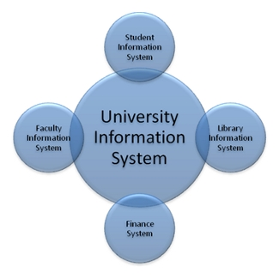 (EL-GHAREEB, 2009)

* + 1. **Conclusion on Information System**

As discussed, there are three main information systems: Decision support systems, Expert system, and Management information system. By looking at each of these different approaches to information systems, it is clear to see a shift towards decision-making systems.

The Decision Support System theory shows the importance of privileges in the system. Each of these different theories led to different approaches to designing information systems.

* 1. **Approaches to Designing an Information System**

As discussed previously, there are several theories about decision making systems. Along with this, there are different ways to approach designing an information system.

The main approaches are:

* Traditional Systems Life Cycle
* Prototyping
* Software packages
* End-user development

Each will be briefly discussed in this section and how they are used in other organization and also how the will help me build the Lab Helper System.

* + 1. **Traditional Systems Life Cycle**

This is also known as the Waterfall model. This is a very formal approach to building a system by dividing the system developed into formal stages that must take place in a sequential order. (Nora, 2008).

This traditional systems life cycle is focused on thoroughly understanding the system before developing, by understanding the purpose of the system and also the system requirements. The traditional systems life cycle consists of several steps which are:

* Systems Analysis
* Systems Design
* Programming
* Testing
* Conversion
* Production and Maintenance

These steps are outlined by Nora, shows how structured traditional system life cycle is. In practice, traditional systems life cycle is still used by different organization when developing applications. It is a good approach to design as it focuses on the system requirements which simplifies the development of the system.

* + 1. **Prototyping**

This consists of building an experimental system rapidly and inexpensively for the end user to evaluate. Users can get a better idea of their information requirements by interacting with the prototype. The prototype endorsed by the user can be used as a template to develop the final system. (Nora, 2008).

The importance of prototyping is that it helps the developers to have a broader understanding of the users’ requirements. This method has been criticized because of it poor system quality and lack of standards.

* + 1. **Software package**

This is a process of purchasing a program that has been written and tested. This approach is known to be cost saving, time saving, quality benefits and also easy to learn because it provides documentation and training on how to use the application. (Nora, 2008).

The problem with this type of approach is the software’s ownership.

Looking at the Lab Helper System, with this approach, the university does not get the code of the system which means the code remains with the supplier. Therefore, if there is a change of requirement from the university, they will be forced to buy software resulting to the system which was bought previously to be put aside.

* + 1. **End-user development**

This is a set of methods, techniques, and tools that enable any user of software systems acting as non-professional software developers to create and modify or extend a software artifact. (Lieberman, 2006).

With this type of approach, the user is in charge of the entire design life cycle. Even though the user is involved in the development of the system, a problem may arise such as lack of quality control and oversight, a lack of control over data in the system and tendency for end-users involved in the project to create a system for their own private use.

* + 1. **Conclusion on Design Methods**

Through looking at different design methods, it is clear that the traditional system development lifecycle is still well used as it provides a broader understand of the system requirements for the developers and by incorporating the end-user development approach to get more of the user’s needs and also to be sure of meeting their requirements.

* 1. **Web-Based Information Systems**

A web-based information system is an information system that uses internet web technologies for delivering information and services to users. (Askenas, 2009). This technology is a software system and is used to publish and maintain data by hypertext principle. A good example is Heriot-Watt University Vision. The system is mainly used to deliver information and services to students and instructors from the university.

The use of web technologies in information systems can greatly aid the user by providing them with flexibility, a more interactive environment and a way to collaborate with other users.

* 1. **Software Development Methodologies**

System Development Methodology is a framework used for planning, managing and structuring the process of developing an Information System.

In this report, I will be discussing different methodologies that will help me in developing the Lab Helper System. Namely:

* Waterfall
* Agile Software Development
* System Development life cycle
* Rapid Application Development
  + 1. **Waterfall Model**

Waterfall Model is a designed process whereby the project is developed in a sequence format used in Software Development processes in which the progress is seen as a flowing steadily downwards through the following phases:

* Requirements Gathering

In this phase, all the system requirements are recorded and documented in the requirement specification document.

Looking at the Lab Helper System, in this phase, I will conduct interviews, surveys and panel discussions so as to get more and concrete information possible from clients so that I should be sure of what they are expecting from the system.

* System Design

In this phase, all the requirements gathered are analyzed and the system design is prepared. System Design help identifies system requirements and also helps in defining overall system architecture.

Looking at the Lab Helper System, this phase will help me study all the requirements gathered and prepare a system design by identifying the system requirements.

* Implementation

In this phase, all the inputs from the system design are collected and the system will then be developed in small programs called Units. Each unit will be tested for its functionality.

Looking at the Lab Helper System, This stage will be used to implement all the inputs collected from the System Design and then develop the system in small units from which each unit will then go through a process called Unit Testing to see if they are doing what is expected of them.

* Verification

In this phase, all the units are combined together into a system after testing them.

Looking at the Lab Helper System, this stage will help me assemble the entire unit and make it a system after testing each unit. Once the program is assembled, it will then be tested for any faults.

* Maintenance

In this phase, whatever issue that may arise on the client side will be solved so as to keep the system updated.

Waterfall Model operates in sequence, which means the developers cannot go back to the previous step one it has been completed; not without starting from the beginning of the project.

Waterfall Model does not offer room for changes or errors. Therefore, an intensive plan should be set at the start of the project and should be followed carefully. This model is used in a highly structured physical environment and complex applications.

A good example of a highly structured physical environment will be Manufacturing and Construction industries.

**Advantages of the Waterfall Model**

* The Waterfall Model enables record keeping of which having such records, enables improvement on the existing program in the future.
* The Waterfall Model gives the client a broader view of what to expect. Which means the client will have a good understanding of the project regarding the size, cost and duration.
* They client will have a good understanding of what the application will do once it has been completed.

**Disadvantages of the Waterfall Model**

* The Developers cannot go back to the previous stage once it has been completed.
* The program becomes at risk once the requirements are faulty in any manner because it relies on the initial requirements.
* The project has to start from the start with new codes if errors are found within the requirements.

**Conclusion on the Waterfall Model**

As discussed, the Waterfall Model does not allow changes to a phase once the phase has been completed. Looking at the Lab Helper System, the Waterfall Model will be a difficult model to use because as the system gets developed, some new requirements may arise. Therefore, changes will be implemented without restarting the whole project.

* + 1. **Agile Model**

Agile Model is a software development methodology that helps develop the project in an incremental and rapid cycle; in which the progress is built on the previous functionality throughout the following stages:

* Planning
* Requirement analysis
* Designing
* Building
* Testing

By following the listed stages, each release is thoroughly tested to make sure that the quality of the application is maintained.

Agile Model is also known as a solution to the disadvantages of the Waterfall Model.

The Agile Model gives developers a simple project design as the starting point which they then begin to work on small modules. The work on those modules is done on a certain agreed timeframe which can be Weekly or Monthly sprints. At the end of each sprint, the project properties are evaluated and tests are run.

**Advantages of the Agile Model**

* The Agile Model allows changes to be made after the planning stage which means making changes to the program as the client requires.
* The Agile Model provides an easy way of adding features that keep the application up to date with the latest developments.
* The Agile Model allows the client to provide feedbacks after each evaluation so that evaluation so that they can get the program they desire.

**Disadvantages of the Agile Model**

* As the Agile Model does not have a definitive plan, the final product can be completely different than what was initially intended.

**Conclusion on the Agile Model**

As discussed, the Agile Method is designed as the improvement of the Waterfall Model's disadvantages which means, it allows changes to be made to previous development process without having to restart the whole project.

Looking at the Lab Helper System, The Agile Model will be a good model to use because, As the System gets developed, even when new requirements arise, they can simply be improved from the current system without having to restart the development process of the Lab Helper System.

* + 1. **Rapid Application Development Model**

Rapid Application Development Model is a Software Development Methodology whereby components are developed in parallel as if they were mini projects.

The development processes are time boxed delivered and the combined into a working prototype. By doing so, the client can get something to see, use and give feedback regarding the delivered prototype and their requirements.

Rapid Application Development uses the following phases:

* Requirement Planning.
* User Design.
* Construction.
* Cutover.

**Advantages of the Rapid Application Development Model**

* Helps reduce development time.
* Increases reusability.
* Encourages client feedback.

**Disadvantages of the Rapid Application Development Model**

* Requires highly skilled developers.
* Depends on a strong team to identify the business requirements.

**Conclusion on Rapid Application Development Model**

As discussed, with the Rapid Application Development Model, the project is designed at a time boxed and combined to a working prototype.

Looking at the Lab Helper System, Rapid Application Model will allow me to build the system as a quick working prototype so that the university can test the working prototype so as to provide me with feedbacks.

* + 1. **Spiral Development Model**

Spiral Development Model is a Software Development Methodology with more emphasis placed on the risk analysis.

Spiral Development Model is the combination of the interactive development process model with the systematic, controlled aspect of the Waterfall Model.

The Spiral Development Model has four phases namely:

* Planning
* Risk Analysis
* Engineering
* Evolution

**Advantages of the Spiral Development Model**

* Good for large and mission-critical projects.
* Additional alteration can be added at a later date.
* Software is produced early in the project development life cycle.

**Disadvantages of the Spiral Development Model**

* High specific expertise is required for risk analysis.
* Does not work well for the smaller project.
* End of the project is not known in the early stage.

**Conclusion of the Spiral Development Model**

As discussed, the Spiral Model is a combination of the Waterfall Model and the Iterative development.

Looking at the Lab Helper System, Spiral Development Model will help me develop a System by focusing more on the risk analysis which is good because I will know the severity of different risk. Therefore, depending on their severity, I will either mitigate or avoid the risk. The problem with the Spiral Model is that the end date of the project is not known but while looking at the Lab Helper System, the end date is known. Therefore, everything needs to be planned correctly so as to successfully build the system by the deadline.

* + 1. **Iterative Development Model**

Iterative Development Model is a Software Development Methodology that starts with a simple implementation of the small system developed from the software requirements.

Iterative Development Model helps develop a system through repeated cycles and in smaller portions at a time producing a new version of the software for each cycle of the Iterative Development Model.

Iterative Development Model has 3 phases namely:

* Design and Development
* Testing
* Implementation

**Advantages of the Iterative Development Model**

* It uses Parallel development
* The development progress is measured
* Different risks are identified and solved during iteration
* The software is developed early which facilitates the client's evaluation and feedback.

**Disadvantages of the Iterative Development Model**

* More resources are required
* It is not suitable for small projects.
* The end of the project may not be known

**Conclusion on Iterative Development Model**

As discussed, With the Iterative Development Model, a simple implementation of the system is developed from the project requirements; which means, the project requirements needs to be clearly defined and understood by the developers leading to the system being used while the developers are still developing the system.

Looking at the Lab Helper System, the Iteration Development Model will not be good to use for developing the system because this model requires more attention of the management but with the Lab Helper System, the Lecturers may not be able to give full attention to the development process because they have lectures to prepare.

**Conclusion on Software Development Methodologies**

By looking at each Methodology, it is clear to see a shift towards the Agile Methodology because, when looking at the Waterfall Model, when the project starts to run out of time, testing becomes the only phase left which means that the project is forced to cut the testing phase short resulting in the system being of poor quality.

It is clear that the Agile Methodology is the best Methodology to use because unlike other methodologies, the Agile Methodology provides multiple opportunities for the client and the system developers to get involved with the development of the system which can be before, during and after each sprint.

The Agile Development Model helps the system developers deliver working software early by:

* Valuing individuals and interaction over process and tools.
* Prioritizing a working application over comprehensive documentation.
* Prioritizing the Customers' collaboration over content negotiation.
* Prioritizing responding to changes over following of a plan.

The Agile Model allows the stakeholders to be involved in every step of the development process, resulting in a better collaboration between the stakeholders and the system developers; of which, the system developers gets a better opportunity to thoroughly understand the stakeholders' visions and goals.

Looking at the Lab Helper System, using the Agile Method instead of other models will be an advantage because:

* The project quality is improved by testing the project from day one.
* The project risk is reduced by constantly getting early feedback from the client.
* The system developers stay focused on delivering a subsystem features during each iteration.
* There is an opportunity to change and reprioritize requirements.
  1. **Evaluation Methodologies**

This is a tool that will help me understand how to perform a qualitative and successful evaluation. There are many evaluation methodologies that I can use namely:

* + 1. **Burk and Horton**

This method was developed in 1988 for information mapping method in organizations (Underwood, 1994).

This methodology focuses on:

* Survey staff using questionnaires or surveys.

Looking at the Lab Helper System, to successfully gather information, a survey needs to be conducted and questionnaires need to be answered to get a better understand the System requirements.

* Analyze resource.

Looking at the Lab Helper System, after conducting the survey and getting feedbacks from staff, I will now analyze the available resources to know if they will be good enough to implement the Lab Helper System.

* Identify the strength and weakness of the information resources against the objective of the institute.

Looking at the Lab Helper System, after analyzing the resources, I have to identify the strength and weaknesses that this system contains. If this is done successfully, the institute will be able to implement the system without any doubt.

* + 1. **Booth and Haines**

This is the type of evaluation methodology whereby information is gathered by:

* Identifying and reviewing objectives.

Looking at the Lab Helper System, this stage will help me understand its objectives so that I should know what is expected from it. (Booth & Haines, 1993)

* Deciding what information is needed to meet requirements.

Looking at the Lab Helper System, after understanding it objectives, I have to decide on what objectives are most important and if the implemented objectives meet the University requirements. (Booth & Haines, 1993)

* Conducting an information audit by using questionnaires and interviews.

Looking at the Lab Helper System, after deciding on what information is needed to meet the requirements; I will draft out questionnaires and conduct interviews with staffs and students so as to know if clearly the System will meet the university's demand. (Booth & Haines, 1993)

* Addressing information “gaps” and problems.

Looking at the Lab Helper System, after gathering information from staff members and students through interview and questionnaires, I will now analyze their answers and then identify whether or not the System will be good enough to meet their requirements. (Booth & Haines, 1993)

* Developing an information management policy.

Looking at the Lab Helper System, after analyzing their answers, I will then draft the result in a form of a graph or other formats to illustrate the chosen information and explain how it will improve the problems and gaps faced by the university. (Booth & Haines, 1993)

* + 1. **Buchanan & Gibb**

This the type of evaluation technology used to describe “Universal model as an integrated strategic approach to information audit” (Buchanan & Gibb, 1998)

This evaluation methodology consists of phases namely:

* **Promote.**

Looking at the Lab Helper System, I will use this phase to promote the benefits of the System policy by increasing awareness and the system importance in the university. (Buchanan, 1999)

* **Identify.**

This phase uses the top-down strategic analysis. In this phase, looking at Heriot-Watt University, I will identify and define: the mission of the Lab Helper System. (Buchanan, 1999)

* **Analysis.**

Looking at this institute, after identifying the mission of the System, I will use this phase to analyze and evaluate the University’s information resources and to formulate plans on how the Lab Helper System can improve the situation around the university. (Buchanan, 1999)

* + 1. **Webb**

This is a type of evaluation methodology whereby information is gathered in three different stages namely:

* **Initial audit.**

This is a phase whereby I will have to collect sufficient information as possible so that I should successfully create the Lab Helper System. I will use different strategies to collect information such as getting the university’s profile which will include information on the university’s main aims and objectives in relation to the system. (Vo-Tran, 2011)

I will also collect information on the university’s current system as to help me get an overview of how Helpers are recruited and how the university advertises different available positions to students.

By doing this, it will help me compare the available information resources to the identified information needed.

* **Collecting of data.**

After completing the initial audit phase, I will then use this phase to help me collect enough information through the use of interviews, surveys, observations, group voting and group interviews so as to help me gather information to help successfully develop the Lab Helper System. (Vo-Tran, 2011)

* **Data analysis.**

After completing the process of collecting data, this stage will help me analyze them with the aim of finding answers to questions such as:

What information is needed by the staff to select a Lab Helper?

How is the information collected?

Is the needed information currently being checked before selecting a Lab Helper?

After these questions have been answered, I will have to investigate on what information resources are available but not being used and try to find how to include them in the Lab Helper System. (Vo-Tran, 2011)

* + 1. **Susan Heinzel**

This is a type of evaluation methodology whereby information is gathered using different stages namely:

* **Data collection.**

This phase will help me collect enough information through the use of interviews, surveys, observations, group voting and group interviews so as to help me gather concrete information to successfully develop the Lab Helper System. (Heinzel, 2000)

* **Data analysis.**

This phase will help me analyze data collected with the aim of finding gaps, bottlenecks, and duplications.

The data collected will be analyzed in three different types namely:

* **General Analysis**: this involves open questions, spreadsheet or database programs.
* **Strategic Significance Analysis**: this looks at the system relevance and usefulness to the university.
* **Information flows mapping** this controls the inflows and outflows of information. This helps determine how the system will be used by the staff and students of the university and how the system can be used to improve their helpers' recruitment process. (Heinzel, 2000)
* **Data Evaluation.** After the analyzing process, I will then evaluate the collected data within the context of the university. (Heinzel, 2000)
* **Communicating recommendation.** In this stage, I will communicate the recommendation that was formulated during the evaluation stage and the way at which recommendation should be communicated will be valued by the communication strategy that was developed. (Heinzel, 2000)
  + 1. **Conclusion**

After having evaluated different methodologies, I have determined the best possible methodologies Burk and Horton together with Buchanan and Gibb and Susan Heinzel will be combined to address the identified shortcomings in the information.

With the use of:

* Burk and Horton, I will draft sets of questionnaires (See appendix 1), perform interviews, conduct surveys (See appendix 2) and panel discussions to help me successfully gather information for developing the Lab Helper System.(Anon., 2013)
* Buchanan and Gibb, I will be able to promote the benefits of the Lab Helper System, increase its awareness and it importance. This will also help me identify the mission of the Lab Helper System in relation to the university, analyze information resource and formulate plans to make the system improve the Lab Helper recruitment process, account the advantages that the university will get after implementing those information resources and synthesize a final report and submit to the stakeholders.(Mukherjee, 2013)
* Susan Heinzel, I will be able to plan on how to gather information, collect data after constructing a good strategy of gathering information, analyze the collected data, evaluate the analyzed data, and communicate the recommended data after being evaluated, implement the recommended data and implement the recommended data and then inform the audit as a continuum. (Heinzel, 2000)
  1. **Conclusion**

By reviewing existing literature in the area of Information System, Evaluation Methodologies and Software Evaluation Methodologies, it is clear that there are many areas to research into concerning those areas. Developers have to be aware of the different needs of users, System Requirements, and Design Materials so as to develop a system that will accommodate all of them.

Kolb (1994) identifies different Information System types that can be found by thinking about the system in this way, it helps understand the differences that may occur.

By looking at different Information Systems theories, it is clear that there is a move towards the traditional system life cycle of which this needs to be considered when designing the Lab Helper System.

There are several options for incorporating the end-user development into the development process but this need to be considered carefully and only use if there is a clear need.

Askenas identified the main benefits of considering different Information System Development approach while developing the Lab Helper System.

By looking at different Software Development Methodologies, it is clear that there is a move towards the Agile Development Model of which there is a need to be considered when designing the Lab Helper System; because the Agile Methodology will help me deliver the system on time and also value the client by prioritizing their collaboration.

By using the Agile Methodology, I will be able to be close to the client through every step of the development process which will help me get a better understanding of the system goals and vision. By having the client more involved through the development process, I will be able to get direct feedbacks from them. Therefore, I can be able to make changes to the system if any changes are required so as to satisfy and meet their system expectations.

By looking at different Evaluation Methodologies, it is clear that there is a clear move towards Burk and Horton, Buchanan and Gibbs, and also, Susan Heinzel of which these need to be considered while evaluating the system requirements so as to have a clear understanding of the system purposes, missions, goals, and expectations.

As the system developer, Burk and Horton methodology will help me draft sets of questionnaires, perform one on one interview, conduct surveys, and panel discussions so as to help me gather enough information as possible for developing the Lab Helper System. Buchanan and Gibbs will help me promote the benefits of the Lab Helper System so as to increase awareness and it importance to the university. This methodology will also help me identify the system mission in relation to the university. Suzan Heinzel Methodology will help me plan on how to gather information, analyze the gathered information, evaluate the information then communicate and implement the recommended information.

1. **Requirement Analysis**
   1. **Introduction**
      1. **Purpose**

The purpose of this document is to describe the user requirements for the Lab helper system in much clearer and consistent way as requested by the client. The system will record the course name, Day of the week, start time and duration, start week and end week, skills required and the number of helpers needed for that particular course. (Rodriguez, 2008)

The readers of this document will be the instructor and the developer, System Software Development.

It is intended to be read by:

1. The instructors of the university, so that they know what system they are getting;

And

1. System Software Development as the developer, so he knows what to develop.
   * 1. **Scope**

There is one software system which is Lab helper database. The scope of this project is a fully functioned stand-alone application for the website. This system includes a websites and database.

The database will store the following:

* Personal details of the student.
* Lab helper adverts.
* Course information
* Course duration.
* Skills required.

The main purpose of this database is to give an overview of the lab helper system and record student details with their course choice. This database will enable the instructor to easily upload a description and requirement of the Lab helper they are going to need.

* + 1. **Overview**

This document is divided into two main sections namely: User requirements and System requirements.

Chapter2 gives a general description of the university and also describes the software for the university, the general capabilities, general constraints, user characteristics, operational environment and assumptions.

* 1. **General Description**
     1. **Product Perspective**

This product will be used by the instructors and students of the university. The students will be able to interact with the system but they will be the constraint to their application and also acceptance of their application against their wish. (Bill, 1989)

The administrator will be able to perform special changes in the database if it is needed as well as the maintenance the website.

**Product Scope Diagram**

Admin

C:\Users\6dane_000\AppData\Local\Microsoft\Windows\INetCache\Content.Word\icon_admin.jpg

University database

Browse data

Update data

System



Lab Helper System

Students and Instructors

C:\Users\6dane_000\AppData\Local\Microsoft\Windows\INetCache\Content.Word\gym-icon.gif 

Update data

Update data

Query data

Browse data

Non-University student

Web site

 

Manager

Browse data

Request data

Update data



Generate Report

* + 1. **General Capabilities**

Lab Helper system is a database whereby the instructors of the university can update, upload, delete and view information from the database. The students of the university have access to the positions available and they can apply for them if interested. The non-university students are only allowed to browse the website.

These are the main functional requirements:

1. Allow the instructors to upload labs that require help.
2. Input course name, the day of the week, start time and duration, start week and end week, skills needed and the number of helpers required.
3. Students should create a profile before applying by inputting the skills their poses and then apply for the position most suited for them.
4. Instructors would need to approve their request
5. An automatic email should be sent to the student for confirmation of acceptance.

**Use Case Diagram**

Input labs that require help

Mange Users

Admin

Manage Lab helpers

Input requirements for the course

C:\Users\6dane_000\Desktop\Information for fitness club\images.jpg

Review and approve the students’ request.

C:\Users\6dane_000\Desktop\Information for fitness club\images.jpg

Manage instructors

Instructors

Register on the system

Students

C:\Users\6dane_000\Desktop\Information for fitness club\images.jpg

View and apply for suitable positions

**Allow instructors to Input labs that requires help**

Data is entered by the instructors when they need help with a certain lab. Everything from a number of lab helpers the course name, the day of the week, start time and duration, start week and end week, skills required and the number of helpers needed is added to the database of the system. (Bill, 1989)

Instructors will identify students by their student ID, so a search for a competent student will be by the skills that they have. From the search, a list will come up and when the student is selected, it will illustrate the student’s details.

Search a student

Add course details

Update course details

Input labs that requires help

Delete course details

Instructor Admin

images images

Search all students’ detail

**Allow students to apply for vacant positions**

All the university students will be able to view and apply for vacant positions but only those that meet the requirement will be selected. Because once a position is published by a certain instructor, the requirements of the lab helper that they are looking for will also be published which will make it easier for instructors to select. Every time a student applies for a certain position, an email will be sent to the instructor to inform them. (GUIDE, 2015)

View details of students that applied for the position

Form part of student record

Select the student that meets the requirements

Instructors

images

Inform the student via email.

**Allow students to view, register and apply for the position**

Students will be given options, whether it for web application programming, android programming or desktop application course, these options will be stored on the course details database under each student course selected. Once students have been chosen for that particular course, the advert will become invalid.

Meet the requirements

Apply for the course

View the course

Student Admin

images images

Delete the course advert from the database

Get selected for the course

**Maintaining the database**

All information about the course details and applications of the students will be extracted from the database and used to show the number of students applied for the position.

Maintain all course details and students applications

Admin

images

* 1. **General Constrains**

An SQL database will be used to store personal information of students and instructors and their course. Students will have to log into the site with their username and password so that they should be able to view, apply for vacant positions. Instructors will have to log into to website with their employee ID and password so that they should be able to publish vacant positions. If instructors have admin rights, the instructor will be able to update, delete and edit information.

The quality if the Lab Helper system is constrained by the presence of the deadlines and amount of the time the developer has available to complete the project.

Any data inserted into the database will be validated and verified before accessing the database.

* 1. **User characteristics**

The users of the database will be the following:

* The instructors of the university.
* The administrator of the system.
* University students.

The database will be used routinely every day because data will be coming in every day and tasks will be performed. Inserting, updating, deleting and adding will be done on a daily basis.

* 1. **Specific requirements**
     1. **Capability requirements**

F-UR. 1. **Allow instructor to input Lab that needs help**

**Need: Essential Priority: Phase 1 Source: Heriot Watt instructor**

F-UR 1-1 Add a new lab that needs help

Instructors should be able to add new lab that needs help. This will include course name, the day of the week, start and end time, duration, start week and end week, skills needed and the number of helpers.

F-UR 1-2 Review applications

Instructors should be able to review applications from students.

F-UR 1-3 Select student

Instructors should be able to select the student that meets their requirements.

F-UR 2. **Allow students to view and apply**

**Need: Essential Priority: Phase 2 Source: Heriot Watt Instructor**

F-UR 2-1 View available positions

Students should be able to view the vacant positions available.

F-UR 2-2 Apply for the position

Students should be able to apply for the positions that they most suited for.

* 1. **Constraint requirements**
     1. **Hardware**

NF-UR 1-1 the system shall be installed on front desk computer for student to access.

* + 1. **Software**

NF-UR 2-1 the dataset shall be created using PHP.

NF-UR 2-2 Any faults in the software that has come up within the first 6 months after implementation will be fixed.

* + 1. **Data**

NF-UR 3-1 the system shall be able to store 10000 students with approximately 500 applications from students.

NF-UR 3-2 the system shall not allow invalid data to be entered

* + 1. **Security**

NF-UR 4-1 the administrator will be the only user to access all the system functionality.

NF-UR 4-2 Instructors and students will have to input a username and password which will determine the access level.

* + 1. **Legislation**

NF-UR 5-1 the systems data shall meet the university’s privacy policies.

* + 1. **Usability**

NF-UR 8-2 the system will be easy to learn, easy to understand and easy to use.

1. **Evaluation Plan**
   1. **Introduction**

This is a plan that breaks down the goals and ways in which one will analyze and collect data. This includes the type of data I will be collecting and how I will be collecting them.

This is broken down into two type namely Formative evaluation and Summative evaluation. Of which:

Summative Evaluation Strategy

This is an evaluation strategy that helps evaluate the project as it comes to an end.

Formative Evaluation Strategy

This is an evaluation strategy that helps evaluate the project as it progresses.

For this project, I will be using the formative evaluation strategy to evaluate my progress though the progress development.

* 1. **Purpose**

The purpose of this document is to identify specific errors in the strategies and materials that will be used to develop the Lab Helper System.

* 1. **Method**

Design: this evaluation plan consists of 2 main steps that will each have different goals.

For the first step, I will be conducting two interviews with Dr. Octave as the head of the IT department also the design expert of the University of Kinshasa. These interviews will have the purpose of understanding whether the assessment implementation has been done in the correct way.

For the second step, I will be conducting a one on one evaluation with five different students so as to understand if the lab helper system has been planned and drafted out correctly.

This evaluation will be conducted through interview checklists and surveys. The overall plan of the evaluation is the overall plan chart in appendix A.

* + 1. **Design Expert Review**

**Subject**

Dr. Octave Bonkongola is the head of the IT department in the University of Kinshasa also a design expert with 20 year experience in designing and evaluation software. His education background started with a Philosophy Degree at the University of Lubumbashi and continued with a Master’s Degree in e-learning management in the University of Equateur in Mbandaka. He has worked for four main e-learning companies in Congo and has thought e-learning evaluation process at in ISIPA in Kinshasa for the last seven years.

**Instrument**

The instrument used to draft out this evaluation is an interview checklist. (Appendix B).

**Procedure**

* Discuss the overall purpose, structure and format of the system with the Expert.
* Discuss the specific purpose and planned outcomes of the evaluation with the Expert.
* Interview the expert based on the interview question checklist.
* Ask for any additional comments, questions or recommendations from the expert.
* Thank the expert for his time and effort.
  + 1. **One on one review**

Subjects: this review will be conducted with five different students previously registered as Lab Helpers.

Instruments: the instrument used to structure this evaluation is an interview checklist (appendix C).

**Procedure**

* Discuss overall purpose, structure and format of the system with Lab Helpers.
* Discuss evaluation procedures with Lab Helpers.
* Interview the lab helpers with the interview question checklist.
* Ask each lab helper if they have any additional questions, comments or recommendations.
* Thank them for their time and effort.

1. **Project Plan**

This is a document that elaborates on how to manage a project depending on it size. Looking at the Lab Helper System, this will help explain and break down steps to follow so as the project should be done successfully. (Royce, 2011)

* 1. **Purpose**

The purpose of the project plan is to illustrate the starting and ending point of the project by identifying the task that needs to be accomplished and also highlight any problem that I may encounter during the development of the system as well as to help manage risk.

|  |  |
| --- | --- |
| PROJECT | LAB HELPER SYSTEM |
| CREATED BY | BENI IYAKA |
| DATE | 12.October.2015 |
| EMAIL | [BI34@HW.AC.UK](mailto:BI34@HW.AC.UK) |

|  |  |
| --- | --- |
| *Aim* | The aim of this project is to implement an online system whereby the instructors of the university can update, upload, delete available helper’s positions on campus and The students to access to the positions available and then can apply for them if interested. The non-university students are only allowed to browse the website. |
| *Objectives* | * To automate the communication process between university and students. * To save staff time * To reduce any type of error that might occur while registering * To have accurate information about students |
| *What is the project?* | The project is about designing and implementing an online system that will allow the instructors to upload labs that require help by Inputting course name, day of the week, start time and duration, start week and end week, skills needed and the number of helpers required and students should create profile before applying by inputting the skills their poses and then apply for the position most suited for them.  Instructors would need to approve their request An automatic email should be sent to the student for confirmation of acceptance. |
| *Business need* | * To record details of students interested in helping in the lab. * Informing students about available space. * Ensure that the people interested in join the lab meet the required skills. |
| *Deliverables* | The project will produce an online system that will capture all students details, programs they are enrolled in as well as make known other lab available that the university may have. |
| *Assumptions* | * Interace will be web browser * System will access Students database * System can be accessed remotely |
| *Constraints* | * Project must be completed in 6 months: from October 2015 to March 2016 * Must meet all the customers’ requirements * Must be tested thoroughly before handover to eliminate any problems. |
| *Risks* | * Lack of relevant experience * Technology failure * Timescale risk: deliverable may be produced after project deadline. |
| *Documentation* | Documentation will be kept electronically in a database created for the project. |
| *Decision making process* | System Developer will identify the decisions and consult with the supervisor before final decisions are taken. |
| *Signatures* | B Iyaka |

1. **SCOPE MANAGEMENT**
   1. **Definition**

This is a document that evaluates the work that needs to be done so as to complete the project. Project Scope includes all the work required and only the work required to successfully complete the project.

|  |  |
| --- | --- |
| Project aim and objectives | The aim of this project is to implement an Lab Helper system for the university.  • To automate the registering process.  • To save staff time.  • To reduce any type of error that might occur while registering.  • To have accurate information about Lab Helpers. |
| Project constraints | * Project must be completed in 9 months: from October 2015 to March 2016 * Budget is * Must meet all the customers requirements * Must be tested thoroughly before handover to eliminate any problems |
| Assumptions | * Interface will be web browser * System will access student database * System can be accessed remotely |
| Product requirements | * To record individual fitness plans for members * Allow instructors to upload available labs. * Allow students to view and apply for available labs * Ensure customer satisfaction at all times |
| Project organisation | Every task that will be done during the project will be directly reported to the Project Supervisor for review and approval for the task completed. |
| Deliverables | The project will produce an online system that will capture all customers details, programs they are enrolled in as well as make known other facilities that the gym may have to offer. |
| Early risks | * Schedule Risks, not having enough resources. * Technical Risks, technology failure. * Operational risks. |
| Authority and accountability | The project developer has the authority to make use of company resources to complete the project and make project day-to-day decisions but must report to the project supervisor for involvement in the project |

1. **Change Control Management**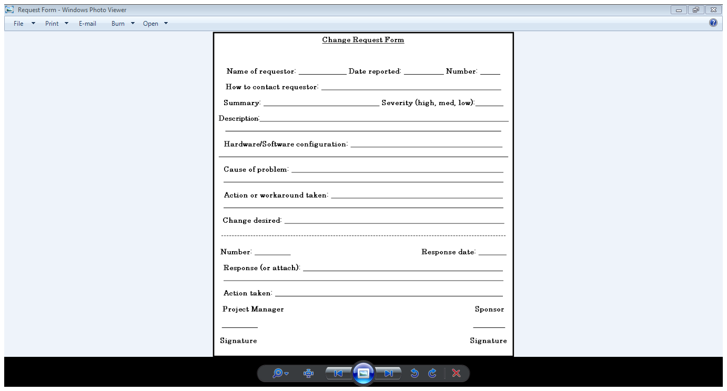
2. **Schedule/Time Management**

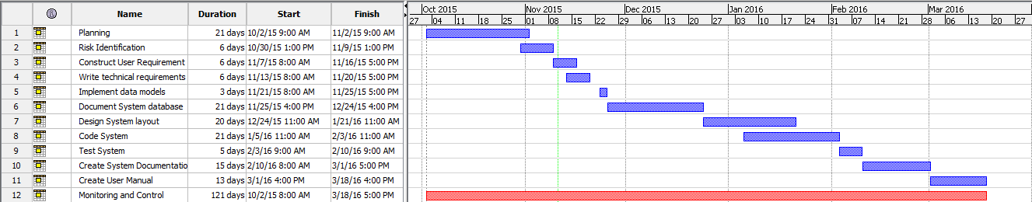

1. **Milestones**

|  |  |  |
| --- | --- | --- |
| *Milestones* | *Date of Completion* | *Responsible person* |
| User requirements document | 28 October 2015 | Beni Iyaka |
| Risk management plan | 09 November 2015 | Beni Iyaka |
| Project Plan | 02 November 2015 | Beni Iyaka |

1. **Quality Management**

|  |  |
| --- | --- |
| *Quality objectives* | *Benefits* |
| Speed | A faster system will be most satifying to the customer. |
| Reliability | The system should be able to provide accurate and correct results. |
| Security | The system should be able to detect any problem and be unhackable and also no should have access to the database containing members personal information. |

1. **Risk Management**
   1. **Introduction**

The Risk Management document will address the possible risks that this project may face during the development stage. The purpose of this document is to identify, control and plan the management of the possible risks in this project. (Bill, 1989)

|  |  |
| --- | --- |
| Risk Factor | Preventive measures |
| 1.System developer’s error | Perform proper research on how to develop the system. .  Pick the most familiar developing language.  Request for help when needed. |
| 2.Unrealistic schedule | Update the schedule as time progresses. |
| 3. Application incompability | Create a compatibility analysis. |
| 4. No matching between Requirements and developed functions. | Create proper Prototyping  Application description in the early phase. |
| 5. The user interface does not fit needs. | Using proper Prototyping,  Create scenarios for development process.  Description of issues. |
| 6.Inadequate architecture, performance, quality | Create simulations.  Modeling,  Tuning of software. |
| 7.Overestimation of own IT capabilities | Technical analysis  Prototyping  Moderate performance and work quality .  Request assistance with task that I’m unable to execute. |
| 8. Availability and compatibility of software compiler used for developing the project | Keep software updated at all times.  Always have a secondary or alternative software compiler that can be used to execute the system .  Create restore points in case of a system failure(data recovery). |
| 9. Data loss | Make back-ups throughout the development cycle. |
| 10. Illness of person of interest | Slow in development while the person of interest is recovering. |

* 1. **Risk Register**

The following terms will be used to determine the type of impacts that I might encounter during the development of the project:

Catastrophic – This represents the highest impacts whereby something tragic could happen with the project.

Major- this is considered as the 2nd highest impacts that the project could happen to the project.

Moderate-This is considered as a fair amount of an impact that could happen to the project,

Minor- This is considered as a minimal impact that could happen to the project.

Negligible-This is considered as the most trivial impact with the very least impact.

The table below displays the probability of the risks occurring within the system and also provides a value that will be associated with the definitions of occurrence. The values are rated from 1 to 5 whereby 1 is the least occurrence risk and five 5 is the most occurrence risk

|  |  |  |
| --- | --- | --- |
| Probability of occurrence | | |
| Definition | Meaning | Value |
| Highly certain | * This will occur most of the times. * This is a risk that willbe continously occuring until a preventative action is taken. | 5 |
| Most Likely | * This is a risk that will be occuring less frequently. | 4 |
| Occasionally | * This is a risk that will be occuring every now and then . | 3 |
| Unlikely | * This is a risk that has a very less chance of it occuring. | 2 |
| Rare | * This is a risk that has a chance close to 0 of it happpening. | 1 |

.

* 1. **Impact with Probability**

The table below displays the severity values which will determine the level of seriousness of the risk that could or would occur depending on its probability of occurrence.

|  |  |  |  |  |  |
| --- | --- | --- | --- | --- | --- |
|  | Probability | | | | |
| Impact | 1 | 2 | 3 | 4 | 5 |
|  | Rare | Unlikely | Occasionally | Most Likely | Highly Certain |
| 5. Catastrophic | 5 | 10 | 15 | 20 | 25 |
| 4. Major | 4 | 8 | 12 | 16 | 20 |
| 3.Moderate | 3 | 6 | 9 | 12 | 15 |
| 2. Minor | 3 | 4 | 6 | 8 | 10 |
| 1. Negligible | 1 | 2 | 3 | 4 | 5 |

Very high risks – these types of risks are values that would range from 15-25.

High – these types of risks are probability values that range from 8-12.

Medium- these types of risks are values that range from 4-6.

Low –These types of risks are values range from 1-3 and determine that the risk has a least amount of probability that it will occur.

\***Red** this means Very high risks (Severity risks).

\***Orange** this means high risks, such risks are likely to happen and there are balances between severity and medium.

\***Yellow** this means Medium risks, such risks can be minor or moderate risks and are possible risk that can occur or may never occur.

\***Green** this means Low risk. This type of risks can be negligible, happens rarely and unlikely or occasionally.

|  |  |  |  |  |  |  |  |  |
| --- | --- | --- | --- | --- | --- | --- | --- | --- |
| NO | Name | Type | Impact | Probability | severity | Indicator | Risk plan | Pre strategy |
| 1 | Unrealistic schedule. | Project Risk | Major | Most Likely  (4) | 16 | \*Project plan reviews | \*keep track of the daily progress rate. | \*Allocate a time frame to project patterns to be completed. |
| 2 | System errors. | Product Risk | major | Most likely  (4) | 16 | Logical errors with the software. | \*Provide an upgrade for the system. solving old problems and creating new concepts. | \*Create multiple testing scenarios . |
| 3 | Overestimation of IT capabilities . | Project | Major | Most likely  (4) | 16 | \*Review quality and standard of my work | \*Use visual tutorials to help with development process . | \*Conducting addition research . |
| 4 | No match between the requirements and developed functions. | Product Risk | Moderate | Occasionally  (3) | 15 | \*when there would be a lack of communication with the client. | \*Implement the concept of rapid application development to gain better understand of project’s expectations | \*Use the system development life cycle concept . |
| 5 | Non satisfactory to user needs during the development stage . | Product Risk | Moderate | Occasionally  (3) | 12 | \*Complaints of the systems restrictions | \*Create prototypes of the logic and systems behavior. | \*Interview the end user to gain an in sight of their preferences |
| 6 | Inexperience / user device and system incompatibility | Product Risk | Moderate | Occasionally  (3) | 9 | \*A failure with installation process. | \*Create more the than one compatibility possibilities . | \*Research the compatibility requirements . |
| 7 | Legacy problems | Product Risk | Major | Most likely  (4) | 8 | \*complaints from user | \*Apply the concept of rapid application design prior to the real life simulations of the system . | \*Implement Prototypes of the system . |
| 8 | Inadequate, architecture, performance and quality of the system . | Product Risk | Moderate | Unlikely  (2) | 6 | \*An early or regular failure of the software. | \*Create Simulations of how the system should work to gain better understanding .  \*Constantly modify the software until it reaches to reach perfection . | . \*Creation of prototypes that would simulate systems behavior .  \*Compare the system with other existing systems that were developed with the best quality . |
| 10 | Availability and compatibility of software compiler used to developed the project . | Product Risk | Negligible | Occasionally  (3) | 3 | \*not having the Compiler that supports the templates and tools needed for the application development . | \*Use multiple mediums of software compilers to develop the application . \*encourage other team members besides the programmer to participate in developer . | \*Used only the basic development complier that had restrictions to some function . |

1. **System Design**

The project’s design is divided into three stages: the website, database, and functionality. The database and the website are being developed in parallel however the functionality depends on the database completion.

* 1. **Website**

The website will be structure into Menu, body and footer.

* The menu will contain the project title.
* The body will contain contents based on dynamic functionalities.
* The footer will content links for contact and help.

**Footer**

**Body**

**HEADER**

**Figure 3 Website layout**

* 1. **Database**

The database has been built using MySQL of which the design is as follow:

Figure-4 Database layout



* 1. **Functionality**

Using the Use Case Diagram, I will give a visual representation of the functional requirements.

* + 1. **Administrative activities**

Accept/Reject New Users

Calendar

Modify Personal Derails

Budget

Admin

View Reports

images

Overview

Accept/Revoke Credentials

Access Security Panel

Deactivate users

The following figure represents different activities that an administrator would perform on a regular basis in the system.

* + 1. **Lecturer Activities**

Modify personal details

Add Module

Accept/Reject Helper

Modify module details

Lecturer

Modify course

images

Join Module

Search Helper

Recommend Helper

Browse Helper

The following figure represents different activities that a lecturer would perform on a regular basis in the system.

* + 1. **Helper Activities**

Modify personal details

Accept/Reject recommendation

Select/delete skills

Search module

Helper

Apply for module

images

Browse module

View reports

Calendar

Overview

The following figure represents different activities that a helper would perform on a regular basis in the system.

1. **Implementation**
   1. **Directory Structure**

To improve access as well as code reusability the files used to generate the website pages are contained in a root folder called “My lab”. The centralization of the code enables it to be installable on any web directory the user has access to.

The main web page file is contained in the root directory along with the database file ‘connect.php’ and ‘functions.php’ which are used by ‘home.php’ (see figure below).

**Figure 5-Root Directory Files**

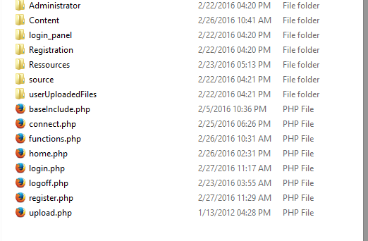

* 1. **Database**
     1. **Database Connection**

To enable the connection between the Database and the website, from the root folder open connect.php and change the appropriate settings to meet your SQL database settings.

Figure 6 – Database Settings

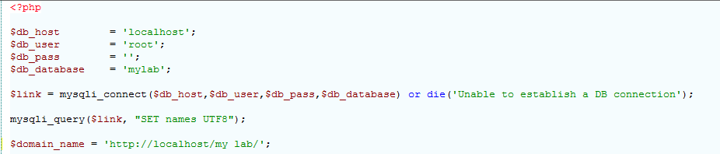

* 1. **Features**
     1. **Overview**

All the features that were developed in relation to the requirements guidelines are individually created in the “content” folder in the main directory. They are properly named and some contain some naming similarities so as to helping the recognition of the file needing to be changed.

* + 1. **Database Features**

The database has been encoded with the UTF-8 mime type.

* **Database Backup and Restore**

These functions are widely used for maintenance of the database in a web-based application. These functions are only accessible by the administrator under settings.

* **Database Protection**

Database protection against different malicious code has been achieved in serval way. The first step is by catching the code through JavaScript handling on the webpage.

Figure 9 – JavaScript Error Checking

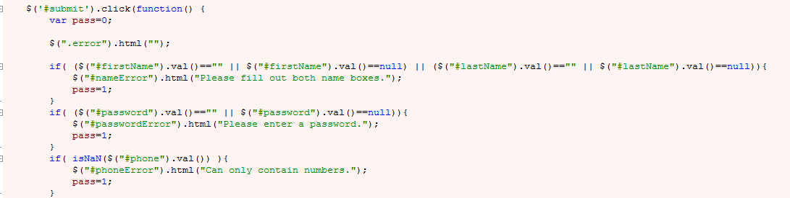

The second step is by finding the PHP parsing of input. This is done by only allowing specified characters and escape dangerous characters that could affect the security and also information breaches. This was done by using PHP built-in security facilities. This limit the user’s control over the values they are passing and secondly escaping special characters using mysqli prepare statements and escape function.

Figure 10 – PHP Error Checking

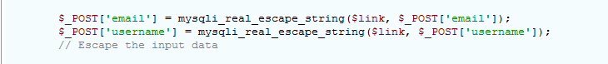

**Access Restrictions**

This system is handled by checking the user’s account type (Helper, Lecturer or Administrator) of which this limits accessibility to areas of the website that is not appropriate to them.

This was done using PHP $\_SESSION variable, $\_GET and $\_POST the sign-in information.

Figure 11- User access Restriction

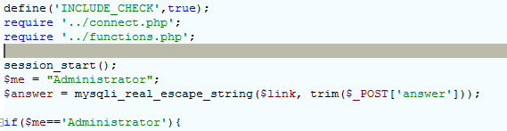

**Form Checking**

This function has been implemented using JavaScript. It instantaneously gives feedback to the user removing the need to revisit the page and retype all information.

Figure 12 – JavaScript Error Checking

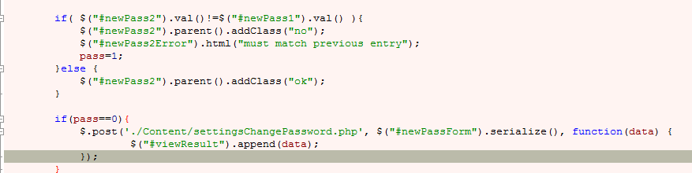

Figure 13 – Form Error Checking

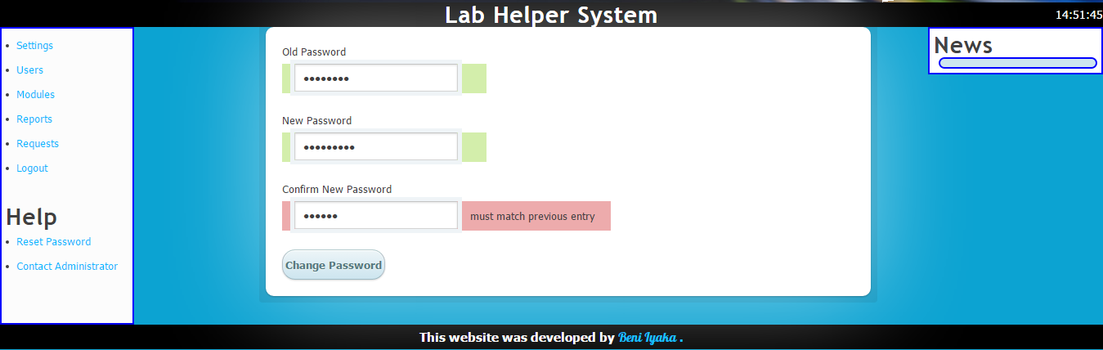

* + 1. **Registration.php**

Figure 7 – Registration page

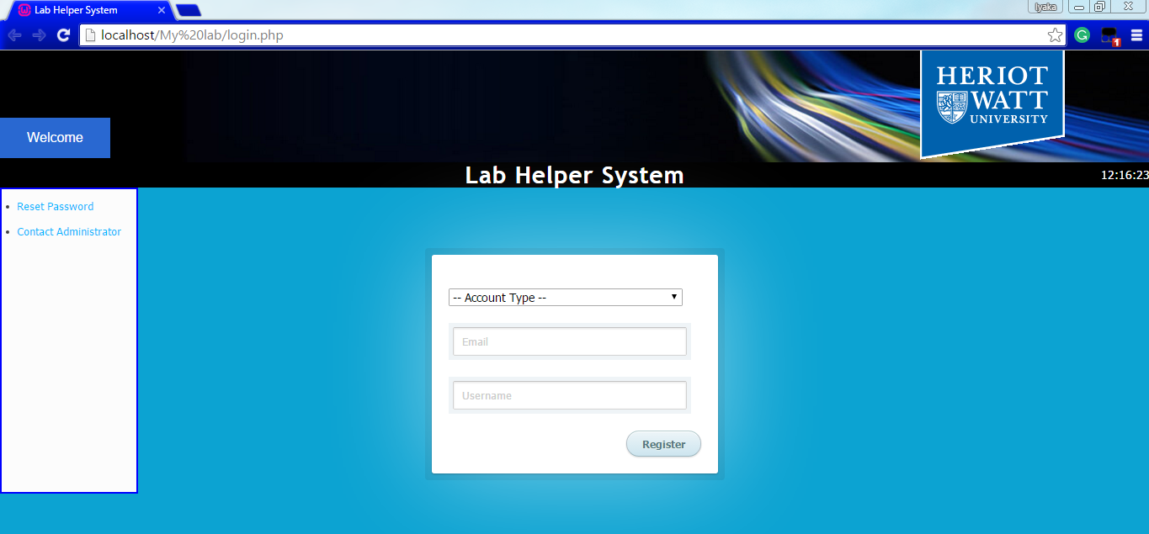

In the registration process, the user is asked to enter their email address and a username they wish to use. These details are then sent to the server and then a login session will be automatically generated which will allow the user to access through the link that is sent to the provided email.

Figure 8 – Registration email

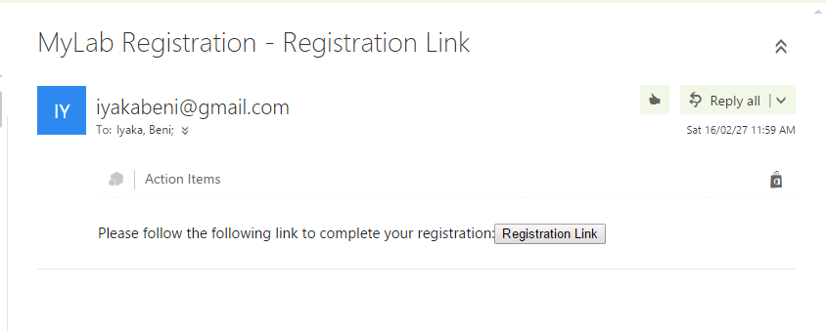

* + 1. **Login.php**

This file is found in the main directory and it is the first page which is displayed when the user tries to access the Lab Helper System.

Figure 7 – Login page

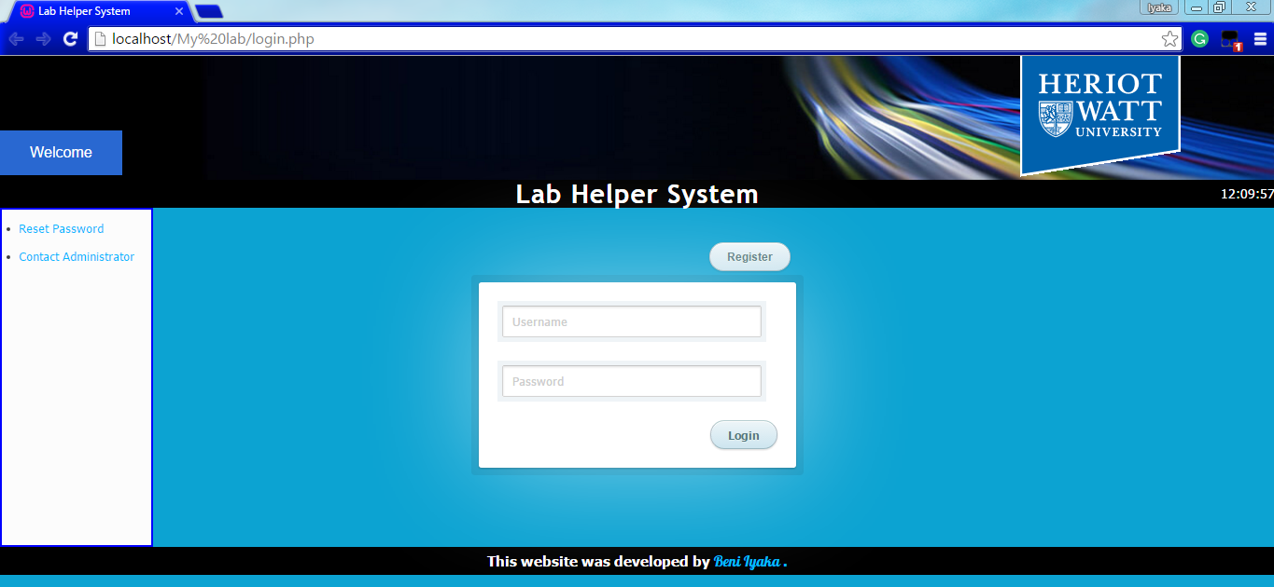

This page also contains the registration page. To access it, the user can simply click on the “Register” button.

The “Login.php” is split into four main parts namely:

* JavaScript Libraries, Fonts and CSS.
* The Header Section
* The validation part which checks to validate the user trying to login or register.
* The footer which contains details/link to the company as well as contact details.
  + 1. **Home.php**

This page is found in the main directory and it is the controlling file. It loads contents according to the user’s account type (Helper, Lecturer or Administrator).

This page is divided into two main parts namely:

* JavaScript which handles the imports of pages.
* The main content area which is controlled by the POST and GET requests of which content is loaded according to the request.

Figure 8 – Lecturer/Helper home page

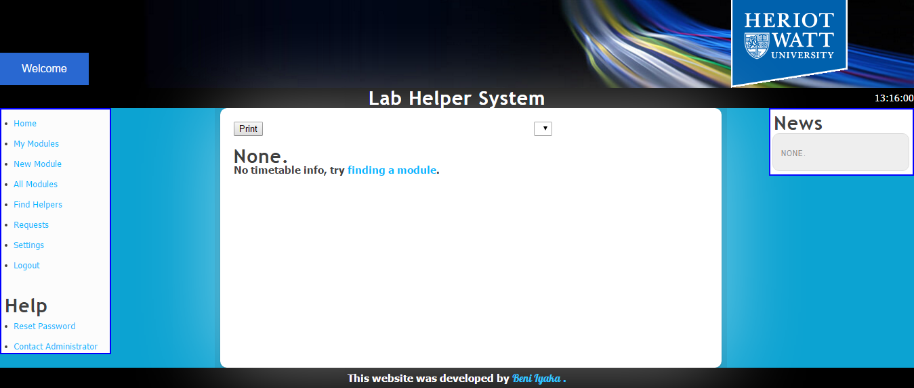

* + 1. **Lecturer Specific Features**
* **New Module**

This page is designed to allow lectures to add new module details to the database. This is highly based on a JavaScript content designed to give the ability to add multiple inputs.

Figure 9 – New module page

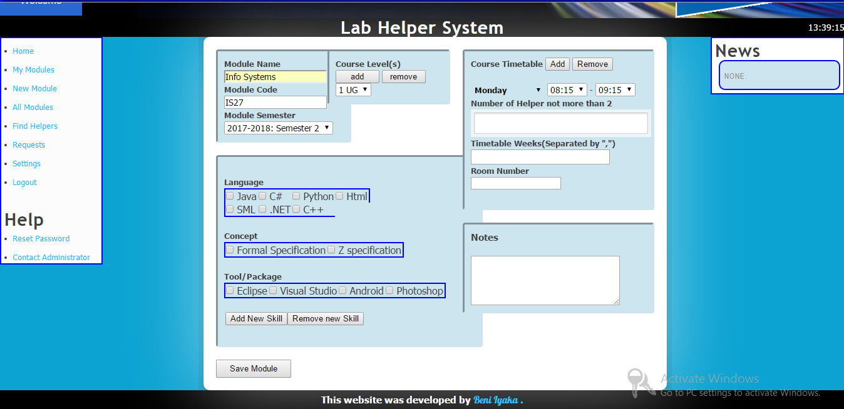

* **Find Helper**

This page helps lecturers to find helpers based on their availability and skills. This process is done by using database queries that match the skills required compared to the ones of available helpers.

* + 1. **Administrator Specific Features**

Figure 10 – Administrator Home page 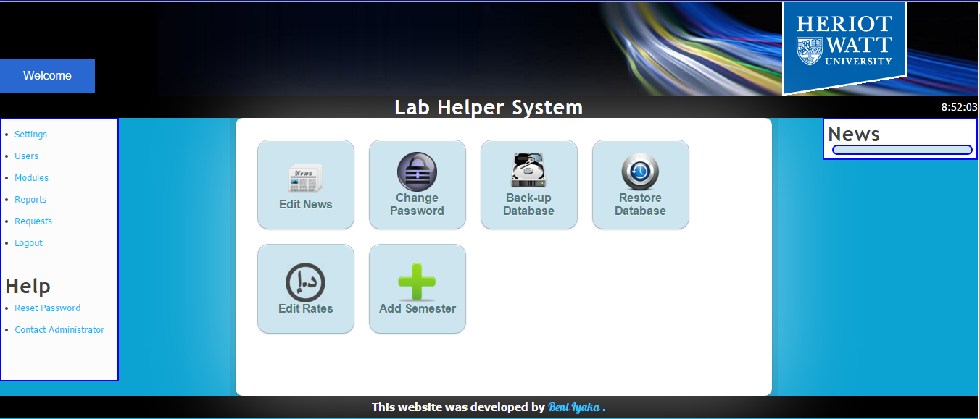

* **View User information**

This page helps the administrator to show information of users based on the semester selected. This information can be the first Name, Surname, Account type and the Modules they are assigned to.

* **View Modules**

This page helps the administrator to show each module’s information. These modules are displayed by semester. The module information includes: Module code, Module Name, Helpers assigned to it and the Module semester.

* **Reports**

This page helps the administrator generate reports based on the helper cost versus the amount of helper hour per semester. So as to keep track of the cost the university spends on Lab Helpers.

* **Edit Rate**

This page helps the administrator to modify the helper’s pay rates by update the value based on the semester selected.

Figure 11 – Edit rate page 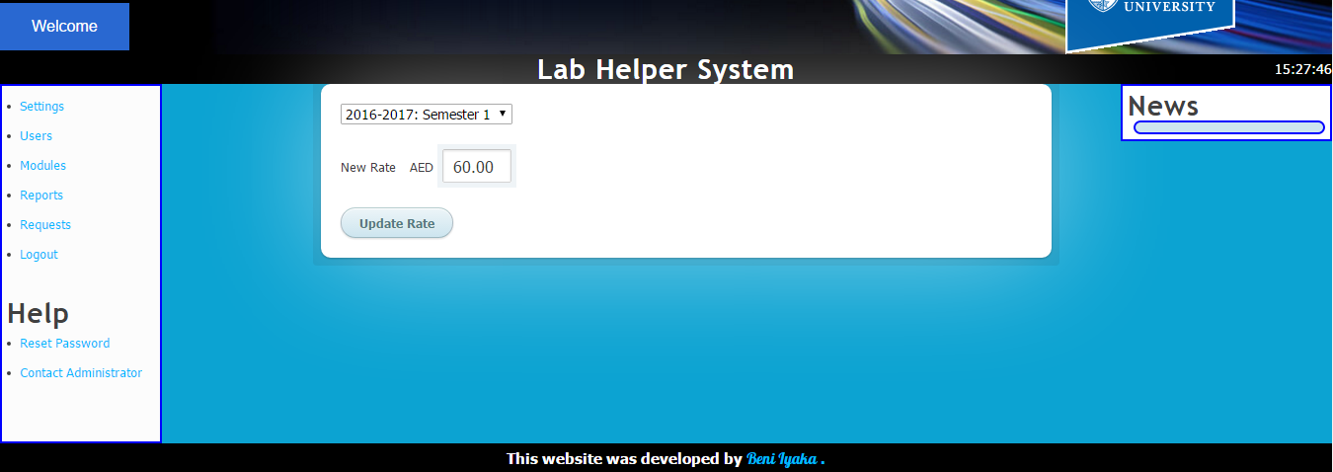

* + 1. **General Features**
* **Settings**
* **Change Password**

This feature helps the users to change their password from the setting panel.

Figure 12 – Change password page

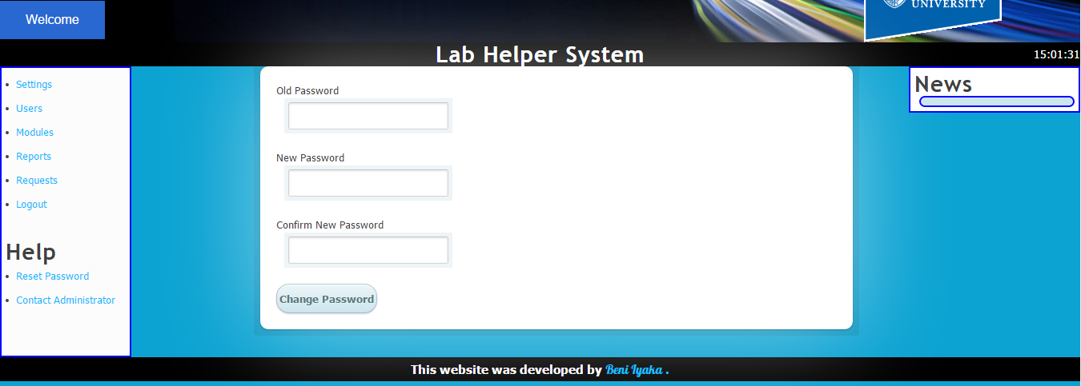

* **Edit Details**

This feature helps the users to change the details like username, first name or phone number.

Figure 13 – Edit Details

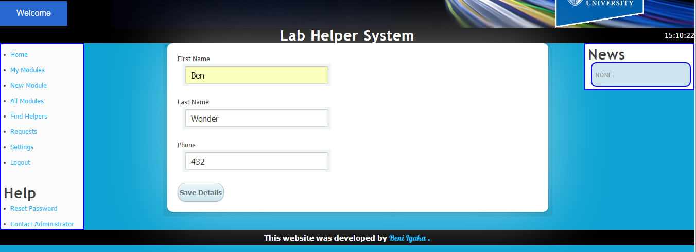

* **Disable Account**

This feature helps the user disable their account. Once the user clicks on the disable account button, the user’s information will still be kept in the database but their account will be disabled preventing the concerned user to access the system.

Figure 14 – Disable Account

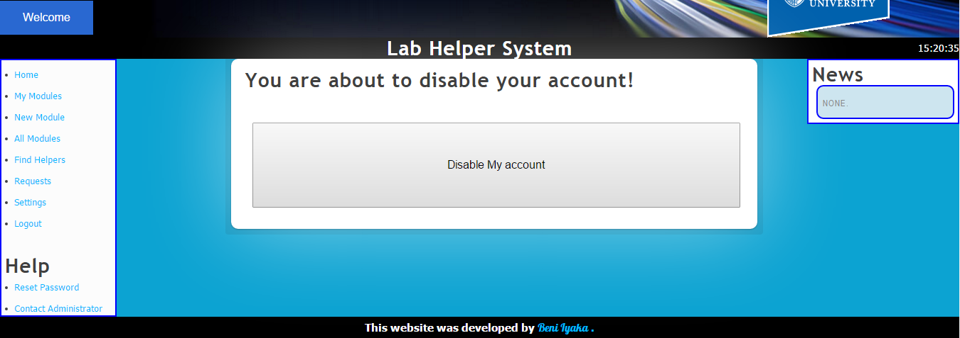

1. **Testing and Evaluation**
   1. **Testing**
      1. **Overview**

To guarantee the system is ready and the weaknesses are known before release, intensive testing must be made on the database.

This is done by inserting and querying on the database through PHP and HTML forms as well as the test by human design.

* + 1. **Database**
* Integrity

This was done by inserting data into tables that are against the relation rules.

* Example

Try to register without an email address.

Insert duplicated records into a table.

* + 1. **Website**
* Security

Table 1 – Security Testing

|  |  |  |
| --- | --- | --- |
| **Scenario** | **Feedback** | **Result** |
| Helper or Lecturer trying to access the administrator page | Throws and error preventing them from viewing content | Passed |
| Administrator trying to join or create a module | Throws and error preventing them from doing so. | Passed |

* + 1. **Acceptance Testing**

Table 2 – Acceptance Testing

|  |  |  |
| --- | --- | --- |
| **Scenario** | **Feedback** | **Result** |
| Register as a Lecturer | Notifies the user that an email has being sent to the provided email address. | Passed |
| Lecturer recieve an email with a link to continue registration | Notifies the user that they have completed their registration and should wait for an administartor to approve their request | Passed |
| Register as a Lab Helper | Notifies the user that an email has being sent to the provided email address. | Passed |
| Helper recieve an email with the link to continue registration | Notifies the user that they have completed their registration and should wait for an administartor to approve their request | Passed |
| Administrator approve users | Notify the user on the decision the administrator has taken | Passed |
| Login as Helper or Lecturer | If administrator has approved the user, then they should be redirected to the homepage. Else Notify the user that they have to contact the a ministrator | Passed |
| Helper join module | Notify the lecture of the module that a helper wants to join their module | Passed |
| Lecturer add module | Notify the lecturer that the module has been added. | Passed |
| Lecturer find helper | Send request to the selected helper | Passed |
| Helper view requests and reply to them | Depending on the Helper’s decision, a message will be sent to the Lecturer | Passed |
| Lecturer view requests and reply to them | Depending on the Lecturer’s decision, a message will be sent to the Helper | Passed |
| Administrator view and reply to requests | Depending on the Administrato’s decision, a message will be sent to the user | Passed |
| Lecturer/Helper view modules | Load module content on the page | Passed |
| Helper leave moodule | Remove the module content from the user’s wall | Passed |
| Print timetable from home page as a Lecturer/Helper | Open the print panel with data ready for printing | Passed |
| Use navigation panel to access other pages | Load pages on acceptable internet connection | Passed |
| Administrator view users’ information | Display all users | Passed |
| Administrator view modules’ information | Display all modules | Passed |
| User change password | Change will be successful only if the password is correct | Passed |
| User change details | Displays the change form | Passed |
| Administrator add news | Displays the form news. News can be for lecturers, helpers or both | Passed |
| User logout | Kill session and redirect to home page | Passed |

* 1. **Evaluation**

The Lab Helper System was built with a focus on 3 different users and therefore 3 different interfaces will be evaluated for a better use as well as useful feedbacks in the case of errors.

* + 1. **Helper Account**

All the System requirements for the helper's interface were successfully implemented. With some feedbacks provided by several colleagues from different age groups and different degree types other than the Mathematics and Computer Science department; an overall feedback was that the design was straightforward, clear and very much arranged with a natural utilization. Where there was trouble in understanding what to do, I changed my design accordingly.

An example of this is placing the navigation panel on the left side of the page as well as putting an icon representing the request page just like some social network.

* + 1. **Lecturer Account**

All the system requirements for the lecturer's interface were successfully implemented. With feedbacks provided by several lecturers from different levels, an overall feedback was that the design was straightforward, clear and easy to understand. Where there was trouble in understanding what to do, I changed my design accordingly.

An example of this was to make use of Bootstrap so as to make my application more user-friendly and also easy to use on different devices.

* + 1. **Administrator Account**

There is only one administrator controlling the system. A new administrator can be added to the system but this can be done by manually inputting detail from the database directly. All the requirements of this account type were implemented and it is easy to use just like the other account types. According to some users’ feedback, some of the features such as backup and restore functionalities will be rarely used but other than that, everything else was clear from the users’ feedback.

* + 1. **Browser Evaluation**

There were some minor problems such as the use of CSS3 based styling which some browser such as Internet Explorer does not support and also the use of Bootstrap to automatically adjust the interface layout depending on the device being used. These problems were fixed and all functionalities should be usable from all the browsers according to the user’s software.

* + 1. **End product Evaluation**

Looking at all the wanted requirement of the Lab Help System, I believe that I was able to meet all of them. Because of positive feedback about how user-friendly and interesting functionalities (such as automatically selecting helpers depending on the Lecturer requirements), I believe this system can replace the old system by providing an easy and more advanced functionalities.

Should the university choose to use this system; some minor changes need to be done to make sure that it completely stable. I am more than willing to do so and would be extremely proud to have my application run in the university.

* + 1. **Summary**

The Lab Helper System is easier to use because it covers work such as emailing back and forth, input by the single administrative user and share tasks to lecturers and helpers. What the Administrator now only has to do is approve the user and view reports with some occasional changes to the database that can be made through the user's interface.

1. **Discussion**
   1. **Achievements**

The initial requirements sketched out essential functionalities to be computerized, and I have executed significantly more functionalities that arranged which increases the ease of use and usefulness of the system. All the objectives of this project have been met.

Some additions (such as grouping the helpers depending on the lecturer’s skills requirements) have originated from some users input and recommendations which have significantly enhanced dependability and usefulness. A solid example of this was when a user is adding a new module sometimes the information would change or maybe wrong, and for that, only lecturers are able to edit them. This function was added so as to make the system more flexible and robust.

My aim was to make professional looking system with a simple layout combined with good functionality. I believe that I have successfully achieved that because of feedbacks I got from different users and the testing of different models.

* 1. **Limitations**

Looking at the lab helper system, it is not ready to oversee itself and still needs an administrator to approve users and also change the helper’s rate is possible. The system does not find helpers automatically for the lecturers; therefore, they have to do it manually.

Adjusting the way the system acts and in addition erasing or altering certain data would require a system engineer to change the PHP, HTML, JavaScript or MySQL database code.

The modification of the way of which the system work would require the system developer to modify the PHP, JavaScript, HTML and the MySQL database code.

* 1. **Possible Improvements**

This system could profit by few extra components:

* Adding a mechanism that will automatically switch to the next week or semester.
* Integration with vision as an accessible tab for every client.
* Adding a mechanism that will automatically extract modules from the university database and update it to the Lab Helper System database modules.

1. **Conclusion**

This project has given me the chance to finish each phase of the product lifecycle, giving me significant experience and additionally showing me what to do and not do next time around.

Throughout the development of the system, I was asking a lot of question but eventually I found out that my vision and interpretation of the given requirements were different. Therefore, I had to seek help and advice from some lecturers from lecturers; of which by doing so, it helped me understand what was needed from the system.

I have discovered that I should be more precise in my questions asking during the gathering stage and subsequently not depend as much on my instinct; I understood this because of the progressions that must be made in the most recent couple of weeks because of a mistake on my part in misconception a key component and prerequisite which obliged me to re-assess my way to deal with it and eventually overhaul the database and the greater part of the usefulness as it affected every last bit of it.

As far as timing, up until the disclosure of the error I had been adhering to the calendar moderately well albeit now I understand that I was excessively strict and not sufficiently adaptable in my arranging as my testing eventually endured and in addition my documentation because of the attention on making the undertaking work.

My supervisor and second reader both remarked on the strictness of the arrangement, and I will be more adaptable and take into consideration more opportunity for revising blunders later on.

The goal was to plan the system so I would be less difficult, less tedious and more organized than the first and also not requiring any training. I trust that I have met this goal, in spite of the fact that I would be glad to continue working and enhancing the system to an upper version with better usefulness, faster reaction times and reconciliation inside of the university, (for example, Vision).

**School of Mathematical and Computer Sciences**

**Ethics Approval**

*Student Projects*

1. Title of project: **Lab Helper System**
2. Supervisor: **Dr. Stephen Gill**
3. Purpose of study: **To develop a system that will help allocate helpers to various labs and provide an interface for 3 different users namely: Helpers, Lecturers and Administrator.**
4. Are human subjects or personal data identifiable with living people involved?

* **Yes**

No

*If NO sign and date the form, otherwise answer the rest of these questions*

1. Is the project mainly concerned with other matters and the only ethical consideration the use of human subjects in interface evaluation?

* **Yes**

No

*If YES and the subjects are staff of students of Heriot-Watt University, no ethical approval is required, except for the requirement for subjects to sign the standard consent forms and to store these consent forms. Data must be anonymised.*

*If NO, then you must complete the full research proposal ethical approval form.*

Please sign the following:

I, the student undertaking the project, certify that this is a true reflection of the intended study, and that I will seek the necessary approval if the nature of the project changes.

Name (please print) **Beni Iyaka**

Signature BeniIyaka

Date **14/11/2015**

I (as the project student's supervisor) have checked the above for accuracy and am satisfied the information provided is a true reflection of the intended study.

Name (please print) **Stephen Gill**

Signature

Date **Human Subject Consent**

Name:

Project Title:

I have been asked to participate as a subject in this project. The nature of the tasks I will be asked to perform have been explained to me in writing (*if possible print the explanation at the foot of this form*).

I understand that I can withdraw my participation at any stage without prejudice.

I understand that all data collected will be anonymized before any publication, unless my prior consent is sought.

Signed:

Date:

# Health & Safety Risk Assessment Form (Project)

## Student: *Beni Iyaka* (print name and sign)

## Project Title: *Lab Helper System*

## Supervisor: *Stephen Gill* (print name and sign)

### Risks:

| ***Risk*** | ***Present (give details)***  (tick if present) | ***Control Measures***  and/or Protection |
| --- | --- | --- |
| Standard Office environment- includes purely software projects | The use of standard office equipment is required. | Nothing |
| Unusual peripherals  e.g. Robot, VR helmet, haptic device, etc. | X | N/A |
| Unusual Output  e.g. Laser, loud noises, flashing lights etc. | X | N/A |
| Other risks | X | N/A |

# Bibliography

Anon., 2013. *Parttime word.* [Online]   
Available at: http://www.parttimeworld.com/images/survey-software.jpg  
[Accessed 24 09 2014].

Anon., 2013. *Thompson River University.* [Online]   
Available at: https://www.tru.ca/\_\_shared/assets/Literature\_Review\_Template30564.pdf  
[Accessed 28 10 2015].

Askenas, L., 2009. *Information Systems.* [Online]   
Available at: http://www.ukessays.co.uk/essays/information-system/web-based-information-systems.php  
[Accessed 2 January 2016].

Beal, V., 2008. *Expert System.* [Online]   
Available at: http://www.webopedia.com/TERM/E/expert\_system.html  
[Accessed 21 December 2015].

Bill, B., 1989. *Software Risk Management.* CA: IEEE Computer Society Press.

Corporation, L.-O. T., 2015. *M6M.* [Online]   
Available at: http://goplextor.com/asia/index.php/sata3-ssd/msata-ssd/m6m  
[Accessed 16 10 2015].

EL-GHAREEB, H. A., 2009. *E-Learning and Management Information Systems.* [Online]   
Available at: http://elearnmag.acm.org/featured.cfm?aid=1621693  
[Accessed 12 January 2016].

Greeno, J. C. A. &. R. L., 1996. *Cognition and Learning.* New York: Simon & Schuster Macmillan..

GUIDE, N. A., 2015. *NONPROFIT ANSWER GUIDE.* [Online]   
Available at: http://nonprofitanswerguide.org/faq/evaluation/what-is-an-evaluation-plan-and-why-create-one/  
[Accessed 16 11 2015].

Lieberman, 2006. *Human Computer Interation.* [Online]   
Available at: https://www.interaction-design.org/literature/book/the-encyclopedia-of-human-computer-interaction-2nd-ed/end-user-development  
[Accessed 03 January 2016].

Mukherjee, R., 2013. *How to prepare for day zero interviews.* [Online]   
Available at: http://startup.nujs.edu/blog/law-interviews-day-zero/  
[Accessed 24 09 2014].

Nora, 2008. *Waterfall Systems.* [Online]   
Available at: http://www.maths.tcd.ie/~nora/FT351-3/Lifecycle.doc  
[Accessed 02 01 2016].

Rodriguez, A., 2008. *Key live.* [Online]   
Available at: http://www.interactive.com  
[Accessed 15 10 11].

Royce, W., 2011. *Managing the development Of Large Software System.* s.l.:IEEE WESCON.

**Appendix A**

**Overall plan**

|  |  |  |  |  |
| --- | --- | --- | --- | --- |
| Phase Evalator | Evaluator | Date | Target | Instruments |
| Expert reviews | Design Expert | 14 November | System analysis, System material and assessment, System Design strategy | Interview questions |
|  | Subject matter expert | 18 November | System Design Analysis,  System assessment. | Interview questions |
| One on one evalution | Lab helpers | 19 November | Purpose, structure and format of the system. | Interview questions |

**Expert Questions**

|  |  |
| --- | --- |
| Questions | Answer |
| Does the evaluation properly identify the problems that the system may cause? |  |
| Does the evaluation properly identify the problems that the system may solve? |  |
| Is the system reaching the intended target? |  |
| How should the planned system be modified to work better? |  |
| What lesson be learned from the way in which the project is unfolding? |  |

**One on One Interview Questions**

|  |  |
| --- | --- |
| Questions | Answer |
| Is the predicted training time adequate? |  |
| Is the System process too complex? |  |
| Is the system layout clear? |  |
| How should the planned system be modified to work better? |  |
| What lesson can be learned from the way in which the project is unfolding? |  |